Assessment:
Reference:
Madden-Lombardi, C., Dominey, P.F. & Ventre-Dominey, J. (in press). Grammatical verb aspect and event roles in sentence processing. PLOS-ONE.
Participants saw rebus sentences in the perfect and imperfective aspect, presented one word at a time, in a self-paced reading task (see Figure 1). In each sentence, the instrument and the recipient of the action were replaced by pictures (John was using/had used a *corkscrew* to open the *bottle* at the restaurant). Time to process the two images was measured, as were time to make a sensibility judgment and the accuracy of the sensibility judgment. Half of the object and instrument pictures did not match the temporal constraints of the verb. For instance, in perfect sentences aspect-congruent trials presented an image of the corkscrew closed (no longer in-use) and the wine bottle fully open. The aspect-incongruent yet still sensible versions either replaced the corkscrew with an in-use corkscrew (open, in-hand) or the bottle image with a half-opened bottle. In this case, the participant would still respond "yes", but with longer expected response times.
Figure 1:
Imperfect aspect:
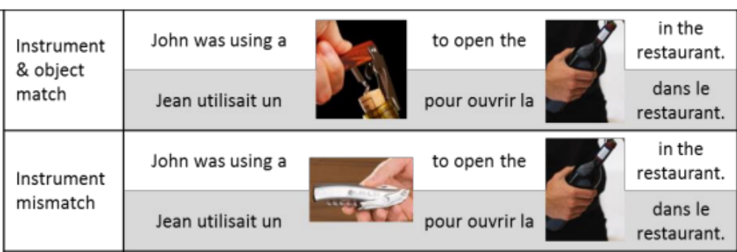

Perfect aspect:
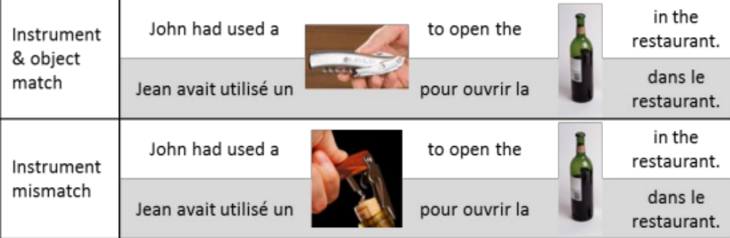

Assessment Instructions
You will be provided with subject-average data from this experiment. You will need to generate a coding script to show how you solve all the bullet points below. The coding script should be annotated to explain what each line of code does.

Data 1: AssessmentData.txt
Variables are as follows:
Subject – participant ID
List Order – order of stimuli
MeanRT – subject mean reaction time
Congruence – picture congruent or incongruent
ImpPerf – sentence tense perfect or imperfect
ObjInstr – object or instrument

- Load in the data
- How many different List Orders were there?
- Check the structure of the data: what format are the different variables stored in? (integer, character, or factor)
- Check the labels for Congruence, ImpPerf and ObjInstr.
How many levels does each one have?
- Change the labels for ImpPerf, so that they are now
‘Imperfective’ and ‘Perfective.
- Generate descriptive statistics for the Reaction Time data and report the means, standard deviation and min/max in the table below

Tense | Object/Instrument | Congruence | Mean (SD) | Min - Max
Perfective | Object | Congruent | 467.45 (126.24) | 292-846
Perfective | Object | Incongruent | 507.36 (144.9) | 294-821
Perfective | Instrument | Congruent | 414.77 (116.8) | 227-697
Perfective | Instrument | Incongruent | 427.32 (107.75) | 234-637
Imperfective | Object | Congruent | 486.23 (131.2) | 233-702
Imperfective | Object | Incongruent | 476.64 (146.6) | 247-824
Imperfective | Instrument | Congruent | 434.23 (120.21) | 264-628
Imperfective | Instrument | Incongruent | 44.23 (120.21) | 227-629

- Generate three interaction plots for the data.
First, plot how Reaction Time changes for Congruence, across Imperfective and Perfective sentences.
Second, plot how Reaction Time changes for Congruence, across Object and Instrument sentences.
Third, plot how Reaction Time changes for Imperfective and Perfective sentences, across Object and Instrument sentences.
What do the graphs show?
- Complete a 2x2x2 within subjects ANOVA for the reaction time data.
What are the results?
- Complete follow up tests (hint: you may have to rerun the anova using afex and lsmeans).
Compare the following conditions:
(1) RTs for Congruent Imperfect Instruments against Incongruent Imperfect Instruments.
(2) RTs for Imperfect Objects vs Imperfect Instruments
(3) RTs for Perfect Objects vs Perfect Instruments
Use bonferroni adjusted p-values.
What are the results?

